CompuRecord Update
June 25, 2004

Effective today, June 25, 2004, the following changes have been made in the Post Op Information Screen. There are now 2 location fields that must be completed.

- Post-Op Location equals Case Close location i.e, PACU, ICU, or Other.

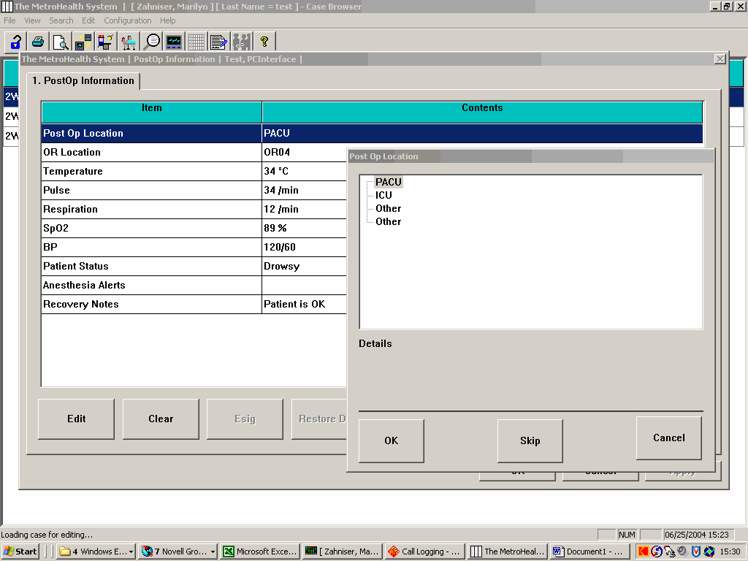

- OR Location is the Operating Room in which the Anesthesia was administered. There is a new drop down box to select the Operating Room Location.

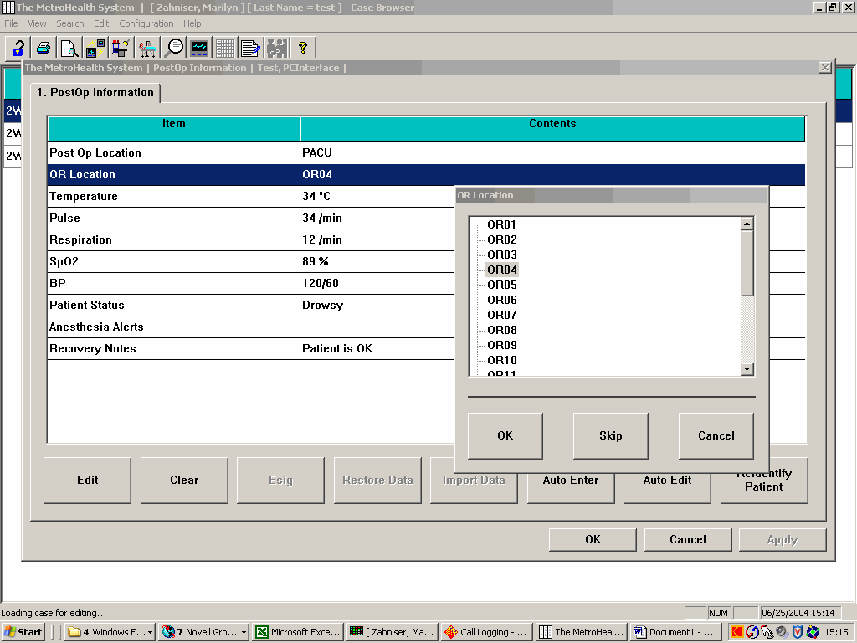

* *The new OR location field is required for the Professional Billing Charge file. **

NOTE: FAILURE TO COMPLETE THE OR LOCATION FIELD WILL PREVENT THE PROFESSIONAL CHARGE FROM PROCESSING!

